**Experiment No: 01**

**Experiment Name: Configure Local Area Network (Wired)**

Step1: Start

Step2: Open Cisco Packet Tracer.

Step3: Take [end device]: PC0, PC1, PC2, PC3, take [Network device]: Switch and use connection wires to connect the devices (copper straight through)

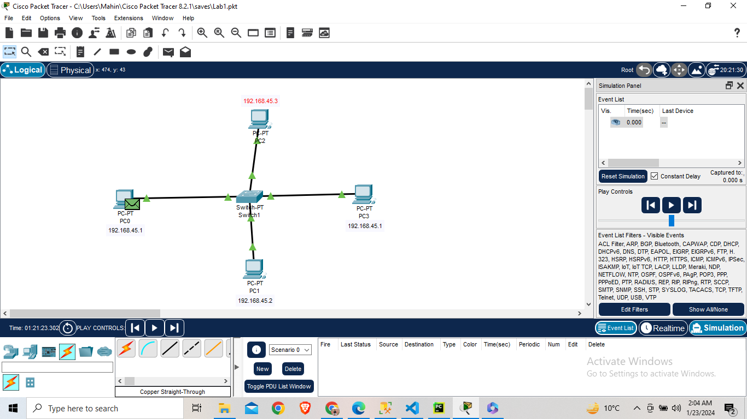 **Fig – Setup Layout**

Step 4: IP Configuration for all end-device

Command like - Click PC0 then Desktop then IP Configuration

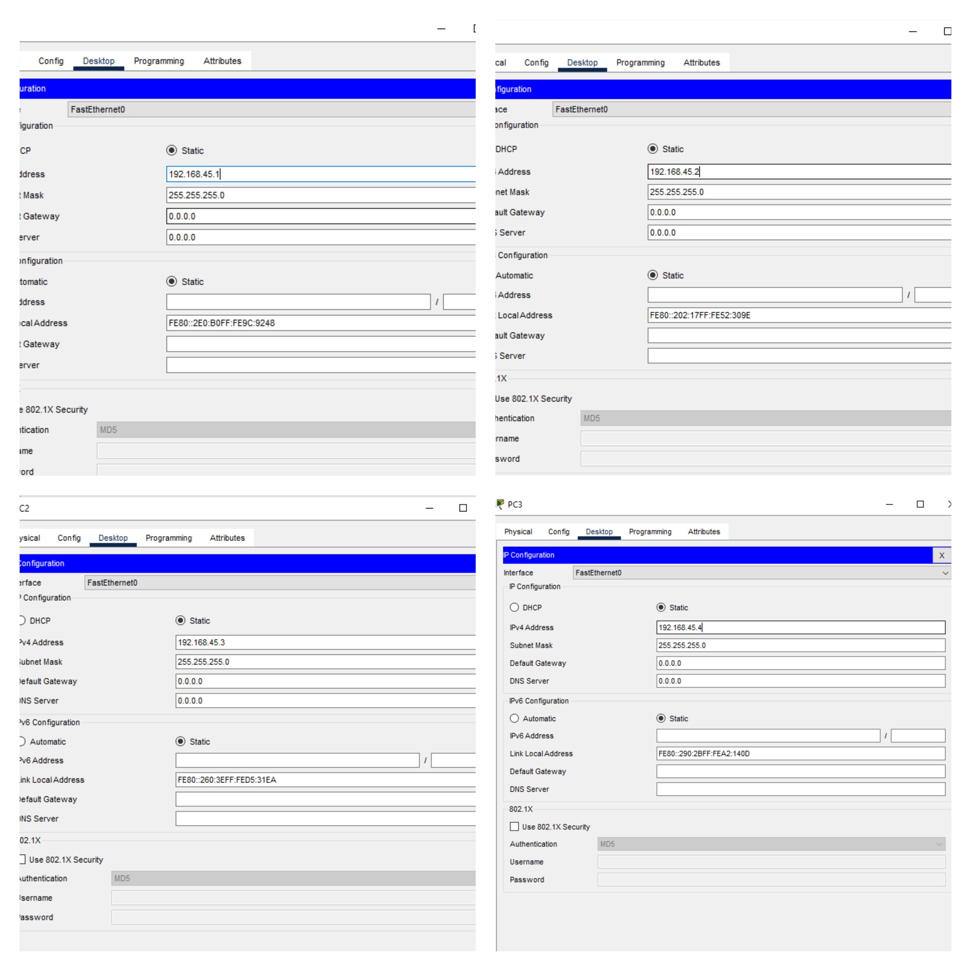

**Fig – IP Configuration for all end-device**

Step 5: Open Command Prompt of PC0 and Sent Ping to PC1

**Output:**

Cisco Packet Tracer PC Command Line 1.0

C:\> ping 192.168.45.2

Pinging 192.168.45.2 with 32 bytes of data:

Reply from 192.168.45.2: bytes=32 time=8ms TTL=128

Reply from 192.168.45.2: bytes=32 time=4ms TTL=128

Reply from 192.168.45.2: bytes=32 time=4ms TTL=128

Reply from 192.168.45.2: bytes=32 time=4ms TTL=128

Ping statistics for 192.168.45.2:

Packets: Sent = 4, Received = 4, Lost = 0 (0% loss),

Approximate round trip times in milli-seconds:

Minimum = 4ms, Maximum = 8ms, Average = 5ms

**Experiment No: 02**

**Experiment Name:** To transfer packet through different network (static routing).

**Procedure**

Step1: Start

Step2: Open Cisco Packet Tracer

Step3: Take 4 end devices PC0, PC1, PC2, PC3 and network device with 2 switches and 1 router, finally set up all the device with copper straight wire.

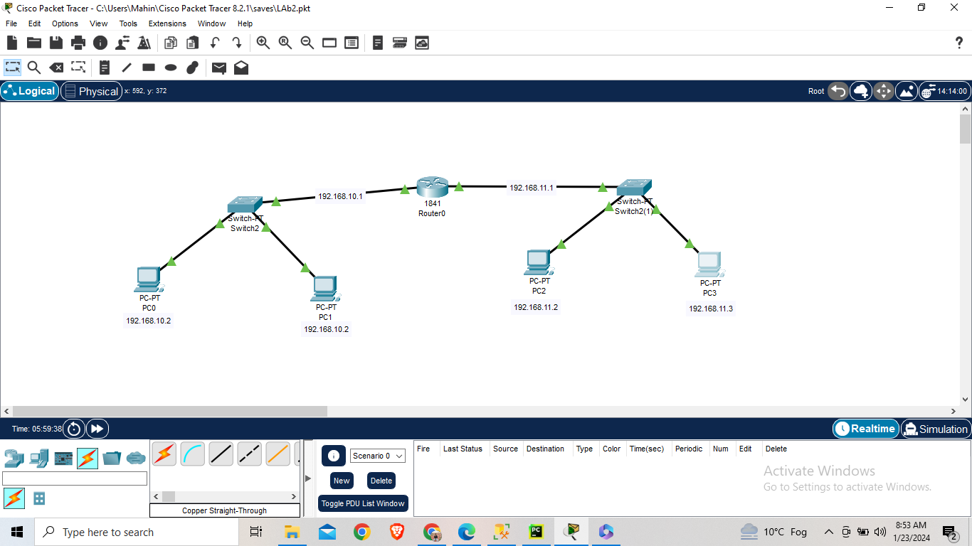

**Fig – Layout of Project**

Step 4: Set up PC0, PC1, PC2, PC3 and Router

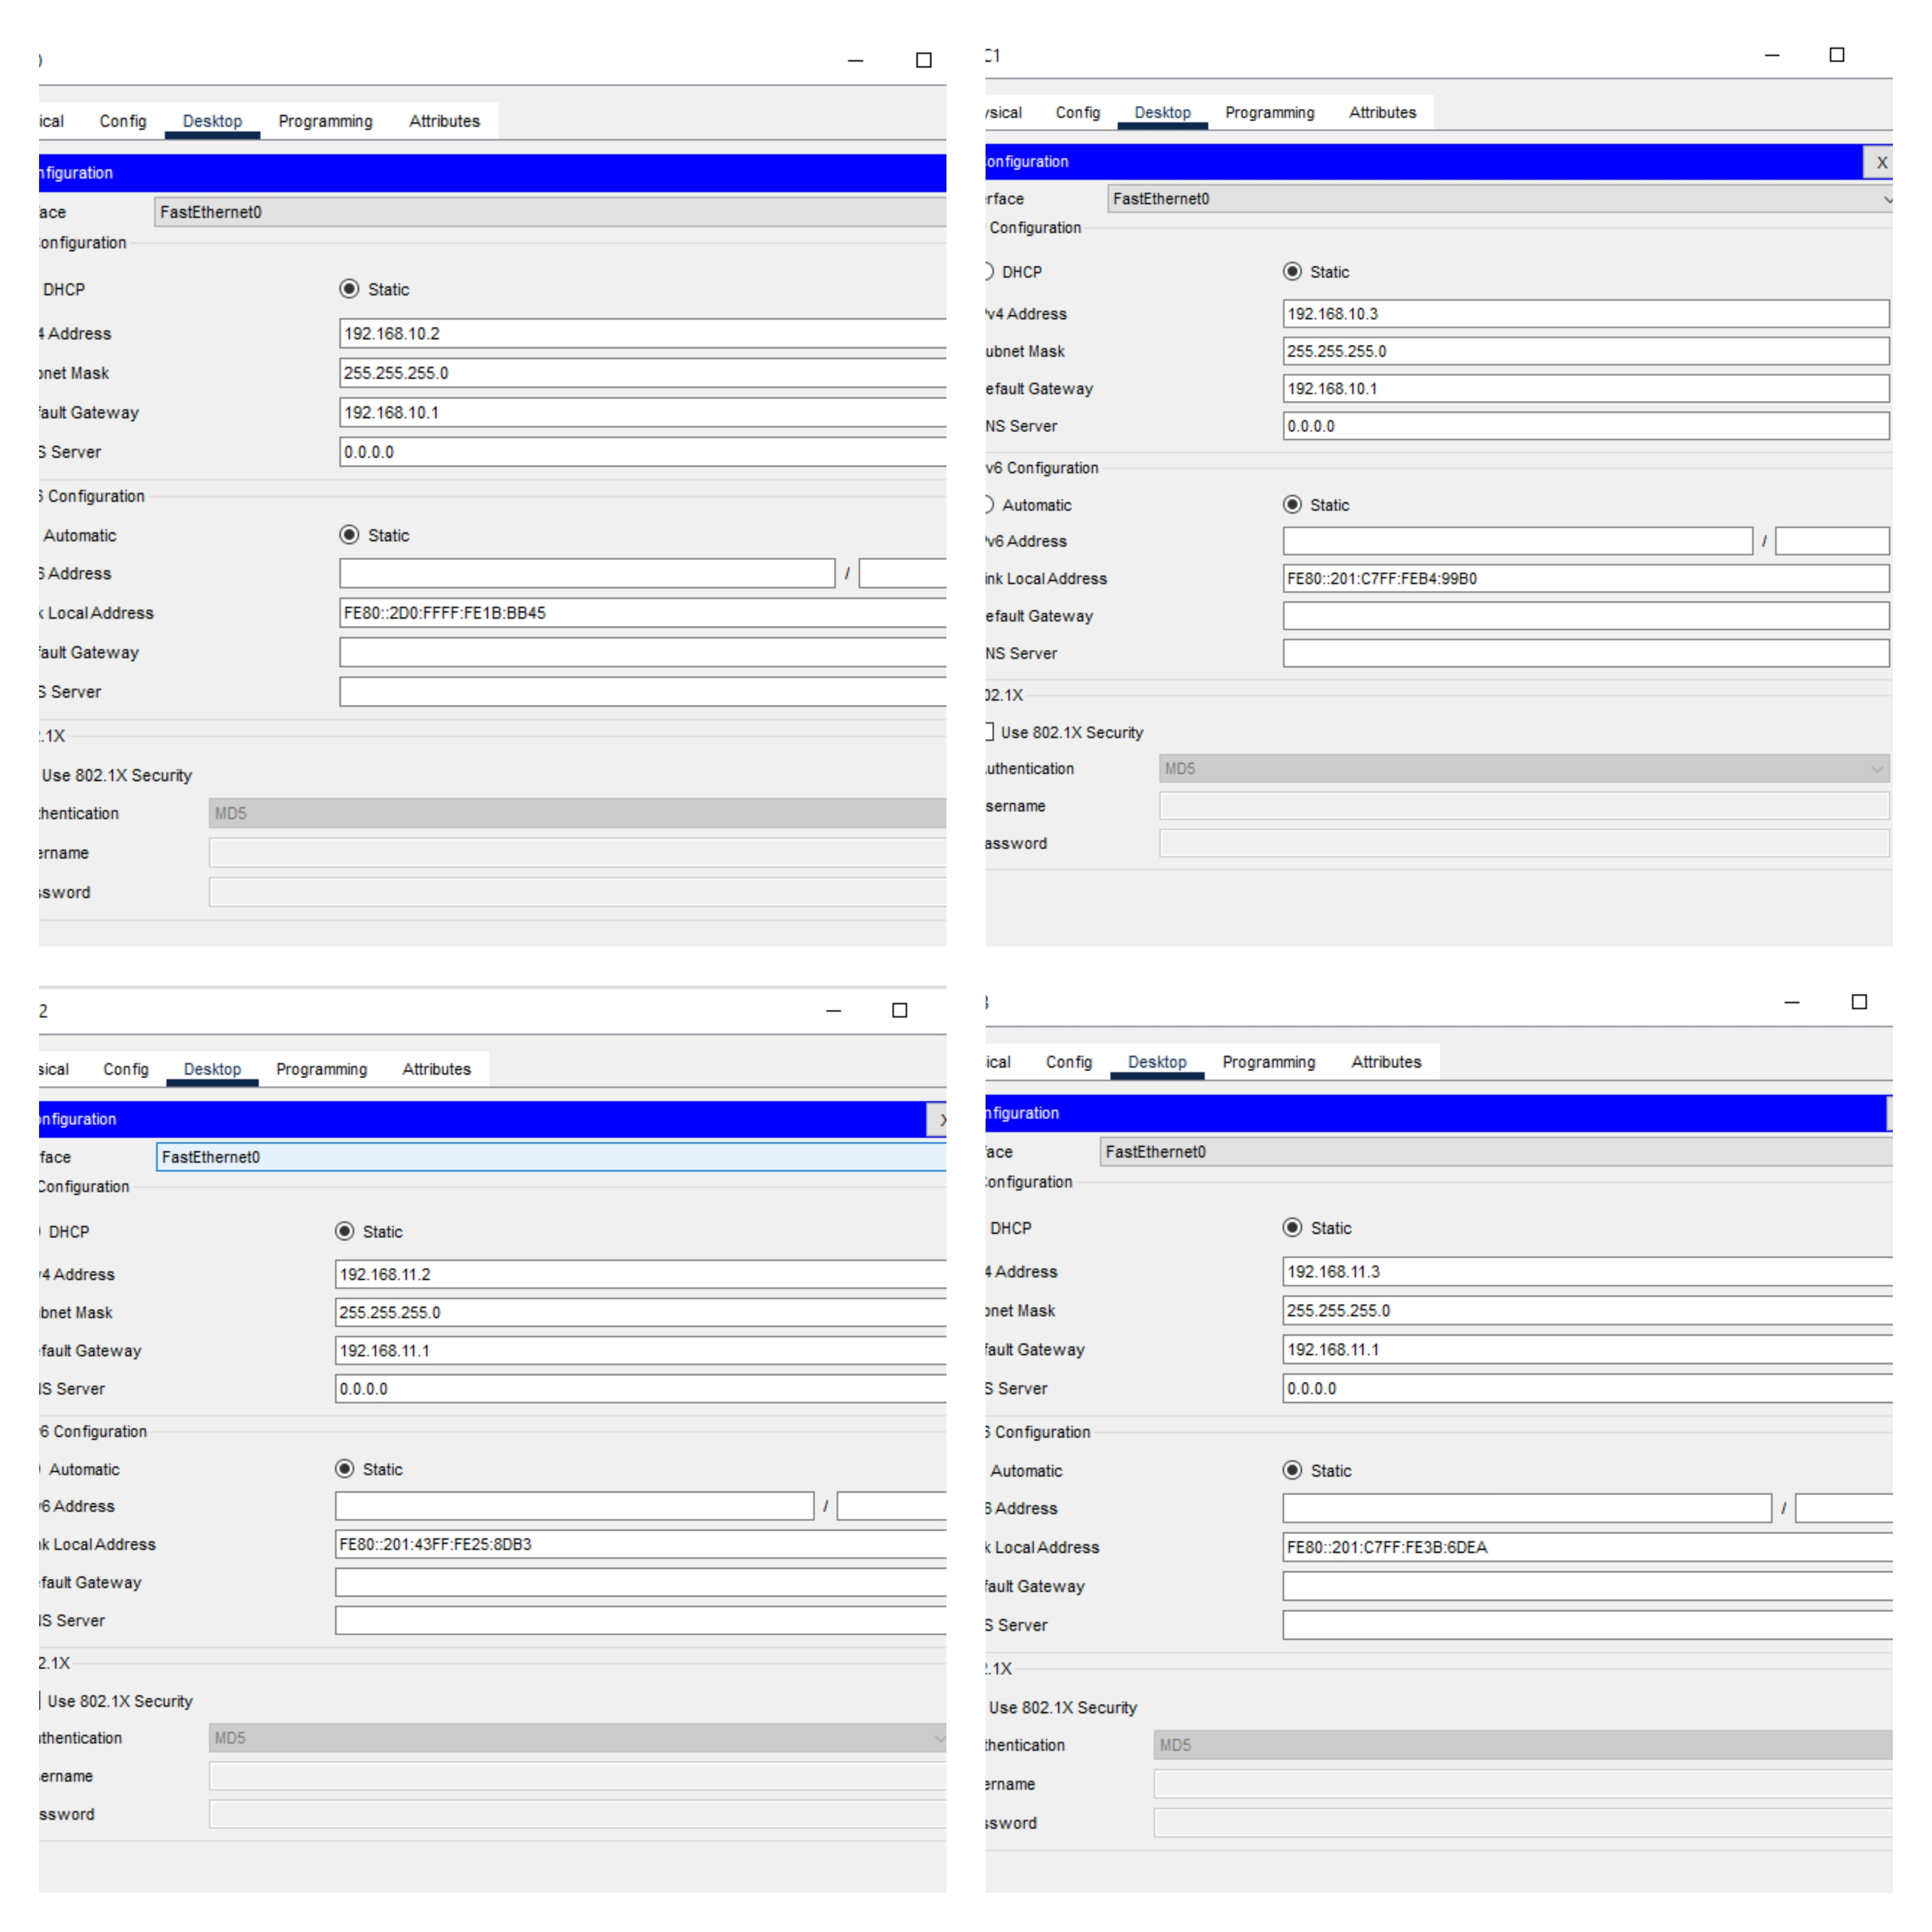

**Fig – Configuration of PC and Router**

Step 5: Router0 configuration.

Click Router0 then CLI then now write command in Configuration dialog.

Router>

Router>enable

Router#configure terminal

Enter configuration commands, one per line. End with CNTL/Z.

Router(config)#interface FastEthernet 0/0

Router(config-if)#exit

Router(config)#interface FastEthernet 0/0

Router(config-if)#ip address 192.168.10.1 255.255.255.0

Router(config-if)#exit

Router(config)#interface FastEthernet0/1

Router(config-if)#ip address 192.168.11.1 255.255.255.0

Router(config-if)#exit

Router(config)#exit

Router#

%SYS-5-CONFIG_I: Configured from console by console

Router#wr

Building configuration...

Step 6: Route Configuration for router0 Click Router1→CLI→now write command in Configuration dialog.

Router>enable

Router#configure terminal

Enter configuration commands, one per line. End with CNTL/Z.

Router(config)#ip route 192.168.10.0 255.255.255.0 192.168.11.2

Router(config)#exit

Router#

%SYS-5-CONFIG_I: Configured from console by console

Step 7: Open Command prompt PC0 and send to PC2

**Output :**

C:\>ping 192.168.11.2

Pinging 192.168.11.2 with 32 bytes of data:

Reply from 192.168.11.2: bytes=32 time=10ms TTL=127

Reply from 192.168.11.2: bytes=32 time<1ms TTL=127

Reply from 192.168.11.2: bytes=32 time=1ms TTL=127

Reply from 192.168.11.2: bytes=32 time<1ms TTL=127

Ping statistics for 192.168.11.2:

Packets: Sent = 4, Received = 4, Lost = 0 (0% loss),

Approximate round trip times in milli-seconds:

Minimum = 0ms, Maximum = 10ms, Average = 2ms

**Experiment No:03**

**Experiment Name:** Transfer packet through two different networks using 2 routers. (static routing)

**Procedure:**

Step 1: